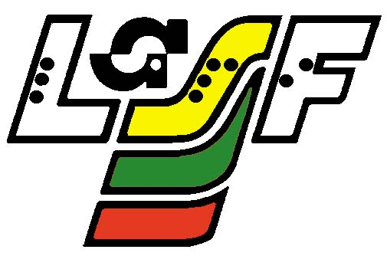

LITHUANIAN BLIND SPORTS FEDERATION

Lithuanian Open Goalball Championships 2016, 1st stage

April 16 – 17, 2016, Vilnius

No. | TEAM | STATE | 1 | 2 | 3 | 4 | 5 | POINTS | RATIO | PLACE
1 | NATIONAL TEAM OF UKRAINE | UKRAINE |  | 9:1  3 | 8:10  0 | 9:15  0 | 13:3  3 | 6 | 39:29 | III
2 | B.S.U. PIRSOS THESSALONIKI | GREECE | 1:9  0 |  | 6:16  0 | 3:13  0 | 6:12  0 | 0 | 16:50 | V
3 | “ŠALTINIS-I”,  VILNIUS | LITHUANIA | 10:8  3 | 16:6  3 |  | 9:4  5:2 | 12:2  3 | 15 | 52:22 | I
4 | “ŠALTINIS-II“, VILNIUS | LITHUANIA | 15:9  3 | 13:3  3 | 4:9  2:5 |  | 8:3  3 | 9 | 42:29 | II
5 | “FIFH” MALMO | SWEDEN | 3:13  0 | 12:6  3 | 2:12  0 | 3:8  0 |  | 3 | 20:39 | IV

Head referee: Rimantas Venckutonis

